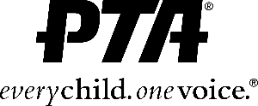
[Click or tap to enter a date.]

Dear [Click here to add name of Superintendent or District Person of Contact],

We are the local PTA leaders for [Click or tap here to enter school district/area name.]. We represent [Click or tap here to enter # of PTAs.] PTAs and [Click or tap here to enter # of members.] members and families in our community.
We understand that OSPI, the Department of Health, and the Governor have released guidance and requirements to school districts regarding options for the Fall reopening of our schools. Knowing you need to hear the diverse voices of our students and families in the decisions you will be making, we request you include local PTA representatives on your parent advisory boards and in the decision-making process. We have representatives from the [Click here to choose a phrase.] who would love to serve the district and the community in this way.
You may contact [Click or tap here to enter PTA coordinator contact name and PTA position.] at [Click or tap here to enter contact information – phone and email.] for the names and contact information of our advocates. They will be serving as our point person for our coalition of local PTAs.
Thank you so much for your consideration. We look forward to working with you, our [Click or tap here to enter name of school district.], in crafting the best learning plans possible for our students.
Sincerely,
[Click or tap here to enter PTA representative name, title, & school representing.]
[Click or tap here to enter a list of as many PTA officers and advocates and schools as you can.]

